Glenview Plan Commission to hear proposal for development at Willow and Pfingsten
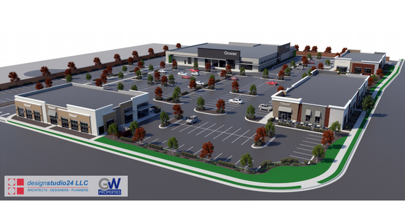
Glenview’s Plan Commission will hear a proposal from developer GW Properties for a project consisting of four single-story buildings totaling up to 63,600 square feet of new retail and restaurant space. Renderings courtesy of the Village of Glenview/GW Properties
Martin Carlino, Contributing Editor
3:00 am CDT August 10, 2019

Plans for a large-scale redevelopment proposal at the southwest corner of Willow and Pfingsten roads are moving forward, months after they were first introduced to Village of Glenview officials.
Glenview officials received an application from GW Properties, the prospective developer, in late July. Glenview’s Plan Commission is scheduled to consider the developer’s final site-plan review application and development plans at its regular meeting at 7 p.m. Tuesday, Aug. 27, according to an email sent to residents from Jeff Rogers, the Village’s planning manager. The current proposed project consists of four single-story buildings totaling up to 63,600 square feet of new retail and restaurant space, according to documents submitted to the village.
A majority of that space would be anchored by a 35,000-square-foot grocery store, with three multi-tenant buildings along the streets, which would include 28,600 square feet of small-shop space.
The documents, submitted by GW Properties Principal Mitch Goltz, say the small-shop space would consist of “a healthy mix of restaurants, retail, medical and service establishments to benefit the community.”
“The mix of tenants will create an active and vibrant shopping center during all hours of the day,” Goltz says in the proposal. “Some users will be more morning-focused, such as a breakfast restaurant and boutique fitness studios. Other tenants will be busier during midday for uses such as quick-serve restaurants, service retail and medical office, and the evening hours will be busiest for dinner-centric restaurants and the grocery store.”
The proposal’s parking plan calls for 318 parking spaces, which exceeds the number required by Glenview’s Village code.
The prospective developer first proposed a rezoning of the subject property, located at 2660 Pfingsten Road and commonly known as the Hart Estate, to allow B-2 general business district zoning over the property’s 8.4 acres of land. B-2 zoning would have allowed the developer to pursue various land uses at the property.
Its first proposal included five total curb cuts and proposed three special uses for the allowance of a gas station, car wash and drive-thru restaurant.
Goltz, on behalf of GW properties, addressed concerned locals in early April at what Rogers earlier described as a neighborhood meeting with approximately 100 residents in attendance. The residents’ initial response to the proposal was “very active and strongly objected,” according to Rogers.
Although the developer initially planned to move forward with its first proposal, plans — and the additional materials needed for Village review — were never officially submitted.
A updated version of the proposal is slated for Plan Commission review because it includes all of the Village’s required materials.
The current proposal eliminates three of the five curb cuts, all of the proposed special uses and the requested rezoning of the property to B-2, Goltz says.
However, opposition from local residents still exists due to concerns regarding traffic and pedestrian safety.
The property is surrounded by high-traffic areas and similar complimentary uses. Plaza Del Prado and Glenbrook Marketplace are situated at the northeast and southeast corners of the intersection. The northwest corner of the intersection, located in Northbrook, is zoned commercial, and could be subject to future development.
Kenig, Lindgren, O’Hara, Aboona, Inc. conducted a 200-page traffic study to review the conditions of the intersection and proposed impacts of the potential project.
The study can be viewed in full on the Village of Glenview’s website.
Details included in Goltz’s summary of the study say while some additional traffic will be created at the intersection due to this project, the proposed intersection improvements included in the project will “help mitigate the increase and result in a safer intersection for all drivers as compared to the conditions as they exist today.”
According to Goltz, the project, which would be done with the help of IDOT and the Village of Glenview, proposes a new right-turn lane on Willow Road and a new, wider sidewalk on Willow and Pfingsten roads for bikes and pedestrians.
Although there’s similar shopping centers nearby, Goltz says GW Properties’ project will offer “more modern amenities.”
“Our project will be designed and built in a first-class manner, which will further add to the strength of the local market and values nearby,” he says. “This project is not pioneering new development, but rather tying into what’s already proven to be successful at this intersection for over 30 years.”
If approved by Glenview officials, the development would break ground later this year.

