Willow-Pfingsten proposal heading back to Plan Commission amid developer’s changes
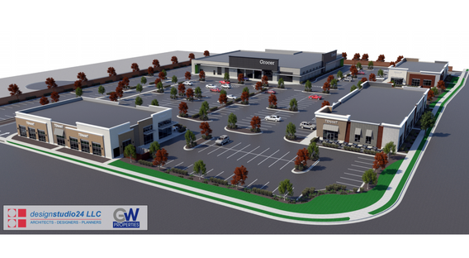
The contentious commercial development proposal at the southwest corner of Willow and Pfingsten roads will now return to Glenview's Plan Commission for further review due to a "substantive change" from GW Properties, the potential developer of the property. Rendering courtesy of the Village of Glenview
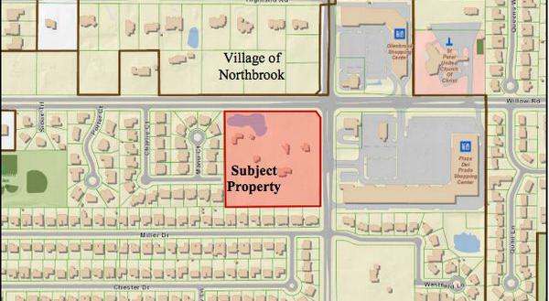
Martin Carlino, Contributing Editor
10:59 am CST November 3, 2019

Locals will have to wait a couple of weeks longer for the latest proceedings on a contentious commercial development proposal at the southwest corner of Willow and Pfingsten roads.
A plan change proposed by GW Properties, the prospective developer of the former Hart estate property, means the case will not be heard by Glenview’s Village Board of Trustees during its Tuesday, Nov. 5 meeting, according to an email from village officials.
The proposal will now return to Glenview’s Plan Commission for additional review due to “substantive changes.”
Glenview officials are scheduled to discuss the proposal at 7 p.m. Tuesday, Nov. 19, at Village Hall. Public comment is welcome at the meeting.
GW Properties’ original proposal for the 8.5-acre site was to construct a new retail development on the north 6.2 acres and a residential component on the south 2.35 acres, as previously reported by The Lantern.
As previously proposed, the development would bring in several commercial buildings located on the north 6.2 acres of the site, including a 35,000-square-foot grocery store and multi-tenant retail buildings totaling 28,600 square feet.
The original proposal also included six new single-family homes, served by a proposed extension of Charlie Court, on the south 2.352 acres.
Glenview’s Plan Commission recommended approval — via a 4-1 vote — of GW Properties’ original proposal in October after a months-long review process that included three public hearings.
GW Properties has now altered its proposal and is instead suggesting the south portion of the parcel have above-ground stormwater detention and tree preservation, with no road extension or residences, according to Glenview Planning Division Manager Jeff Rogers.
Rogers says in an email communication that GW Properties is still requesting to have four single-story buildings with approximately 63,600 square feet of retail and restaurant space on the north portion of the property.
“Because this is a substantive change to the previously recommended plan for approval, the case will no longer be heard Tuesday, November 5 by the Village Board and will be sent back to the Plan Commission for additional review,” Rogers says. “The scope of the review will be limited to aspects of the plan that have changed from that recommended by the Plan Commission.”
More information can be found at glenview.il.us/business/Pages/Ongoing-Projects.aspx.

